**HYBRID FRAMEWORK SETUP**

Steps to configure

**Step1:**

Open Eclipse

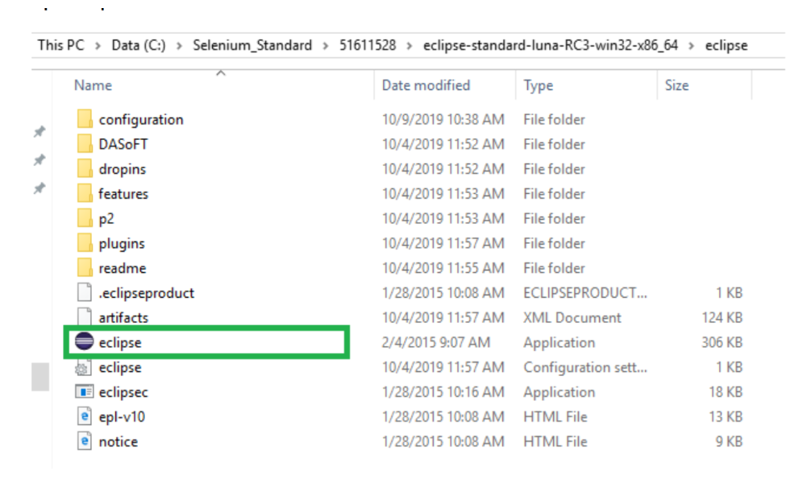

**Step 2:** Select any workspace and click OK button



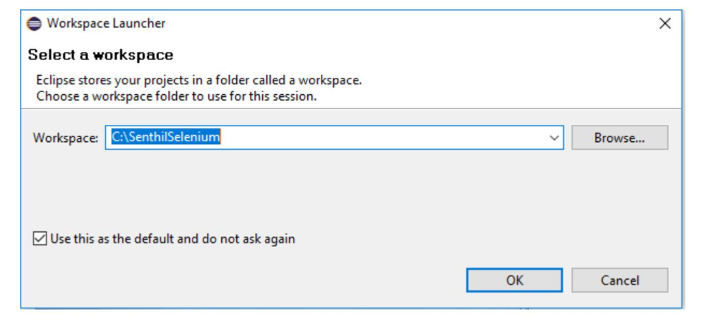

**Step 3:** Once Eclipse open, Go to File->New->Java Project

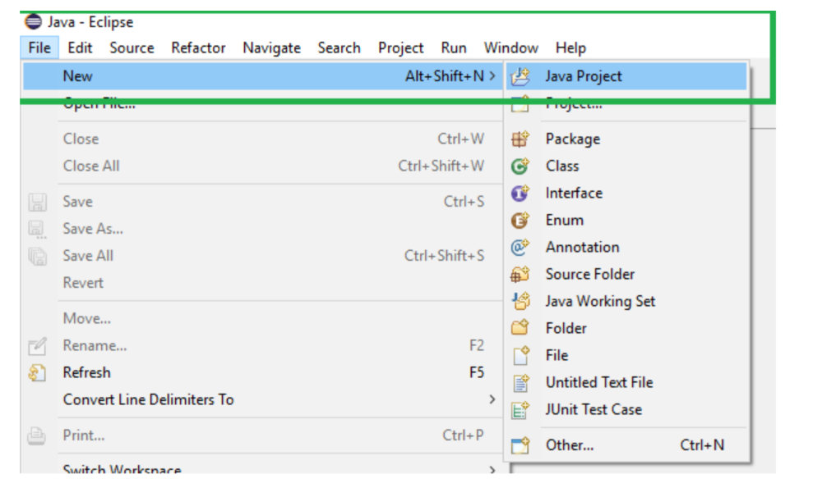

**Step 4:** In New Java project window, uncheck “Use default location” and select the project location (Hybrid Framework location) then click finish button.

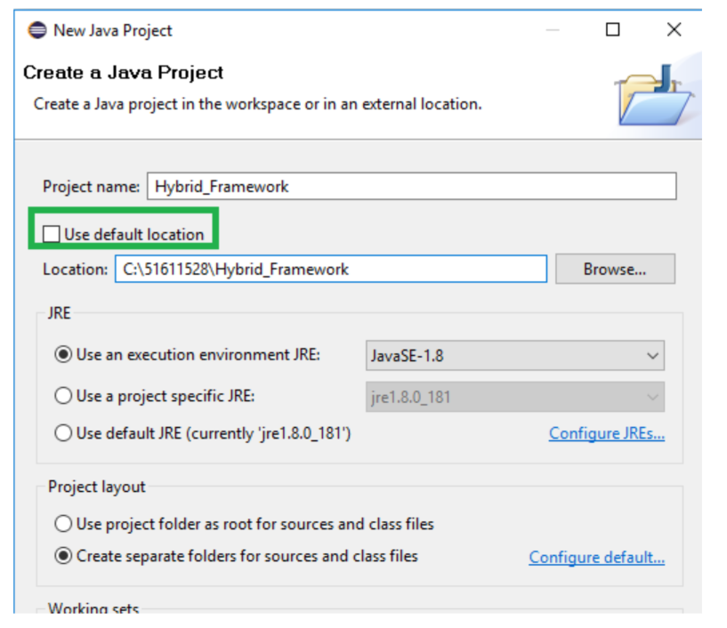

**Step 5:** Project added under ‘project explorer’ tab

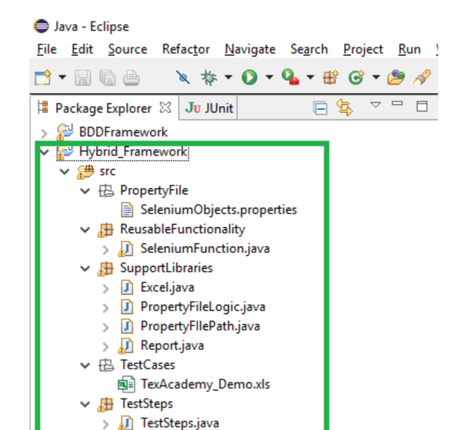

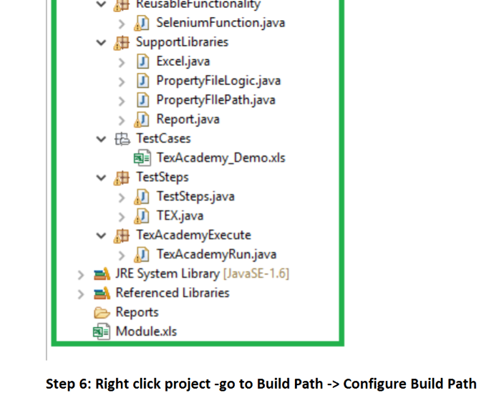

**Step 6:** Right click project -go to Build Path -> Configure Build Path

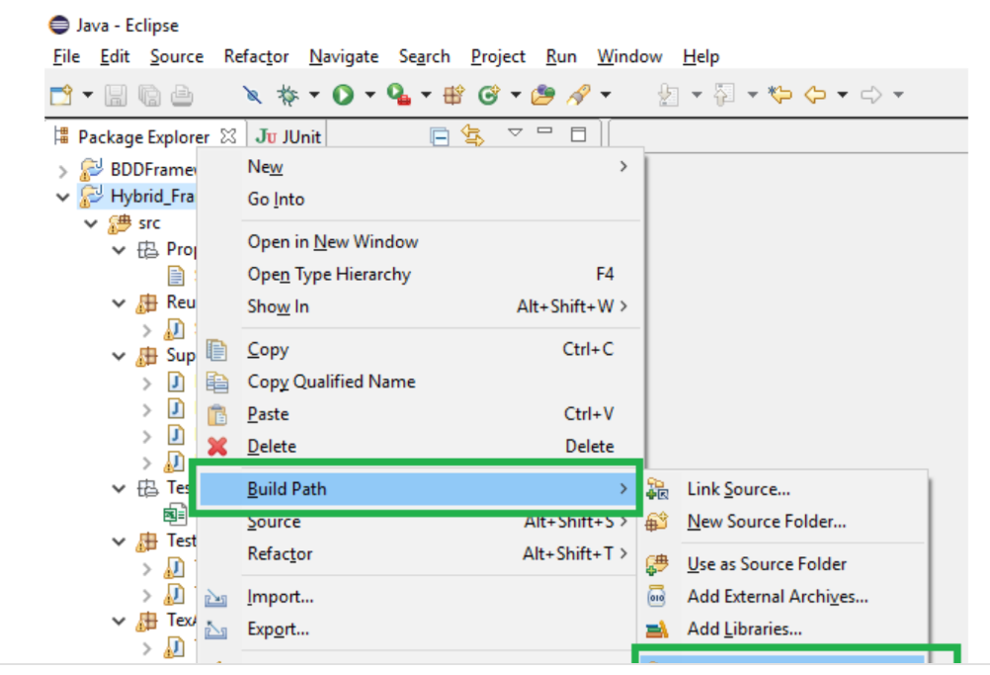

Step 7: In Java Build Path Table Click “Add External JARs” and add below 3 jars. Once Jar added click OK button.

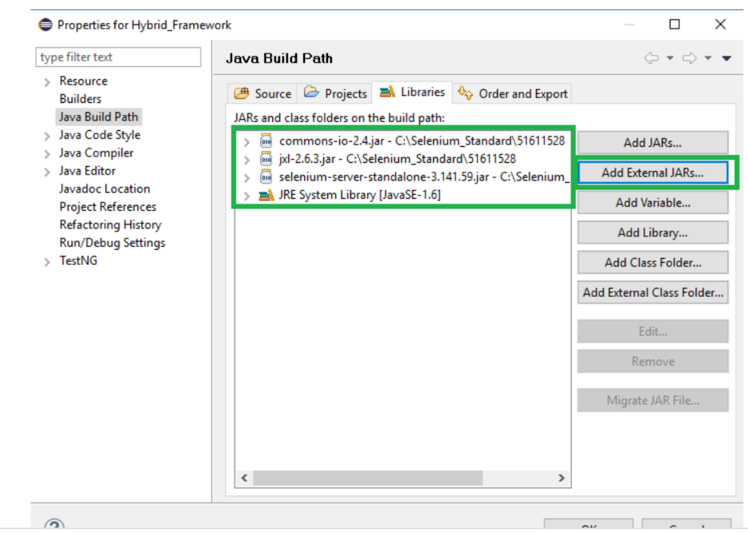

Step 8: Go to “src\PropertyFile\SeleniumObjects.properties” and add the below URL and browser driver path:

URL_Tour=http://newtours.demoaut.com/

IEDriver=C://Selenium_Standard//51611528//IEDriverServer_32.exe

ChromeDriver=C://Selenium_Standard//51611528//chromedriver.exe

GeckoDriver=C://Selenium_Standard//51611528//geckodriver-v0.21.0-win64//geckodriver.exe

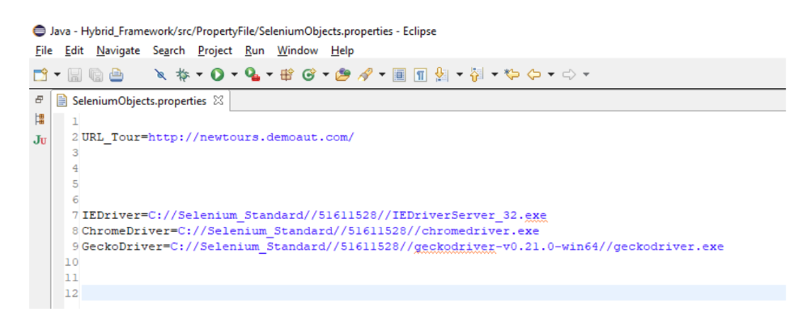

Step 9: Open Module.xls,

create “TexAcademy_Demo” module

then make the status as “Active”

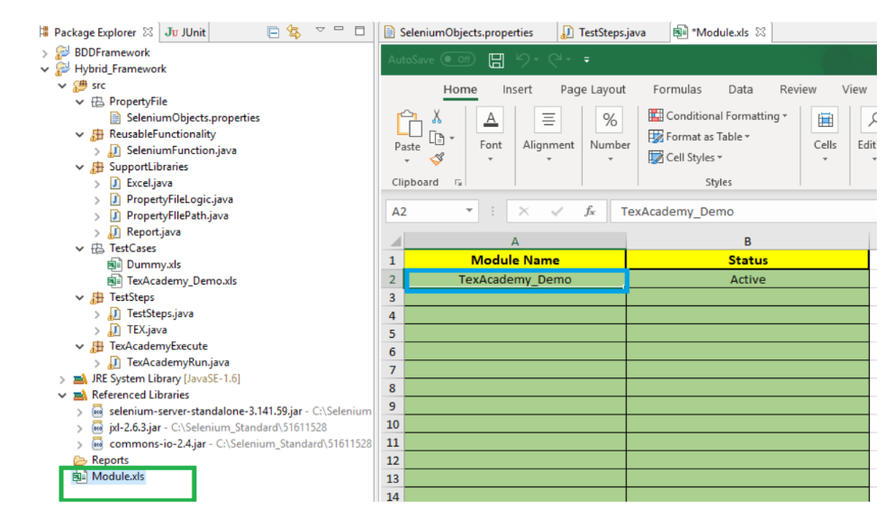

Step 10: Create the module excel (name as TexAcademy_Demo ) under TestCase folder or

Copy and paste Dummy.xls and rename the file (TexAcademy_Demo)

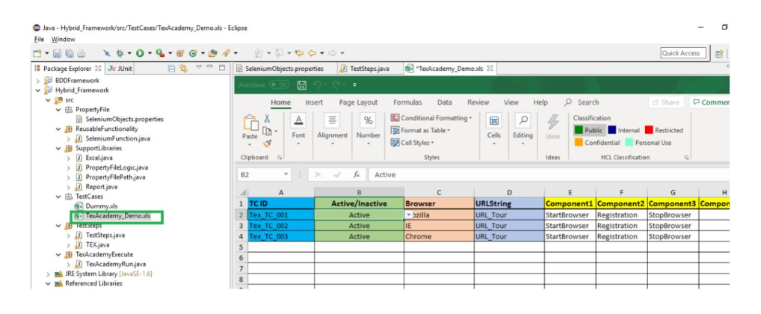

Step 11: Execute the TexAcademyRun.java (right click the java file Run usà java Application)

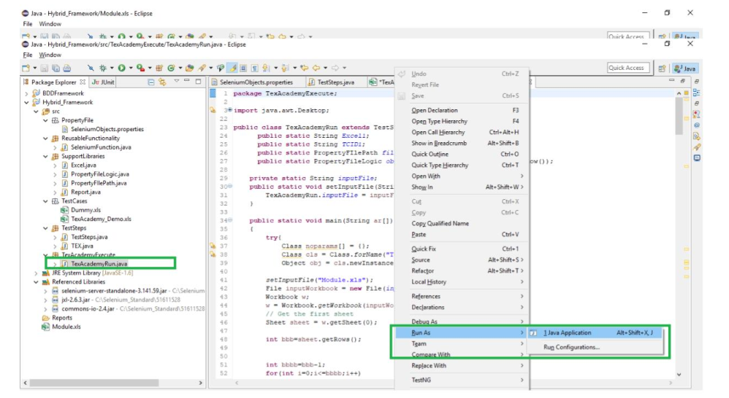

Step 12: Once the execution completed report will be stored in below Report folder:

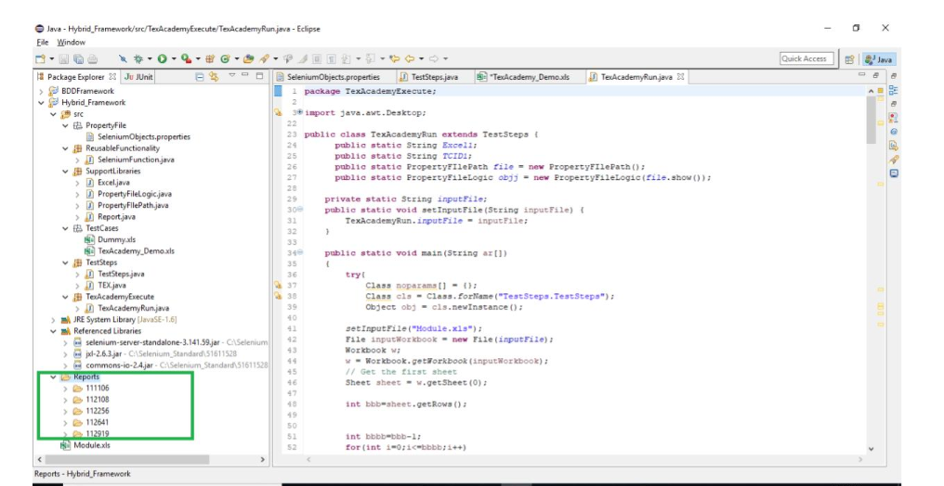

Step 13: Below is the execution summary report

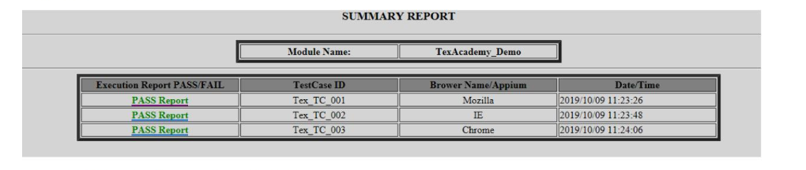

Step 14: Below is the execution test steps for one test case

